Chapter 4, Solution 73

Find the Thevenin’s equivalent circuit across the terminals of R.

10 25
R_{Th}

20 5

10 25

+ + V_{Th} -
60 V + +
-
V_{a} V_{b}
20 5
- -

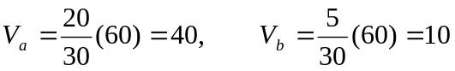

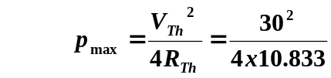 = 20.77 W.

